1. Create RDS Mysql DB

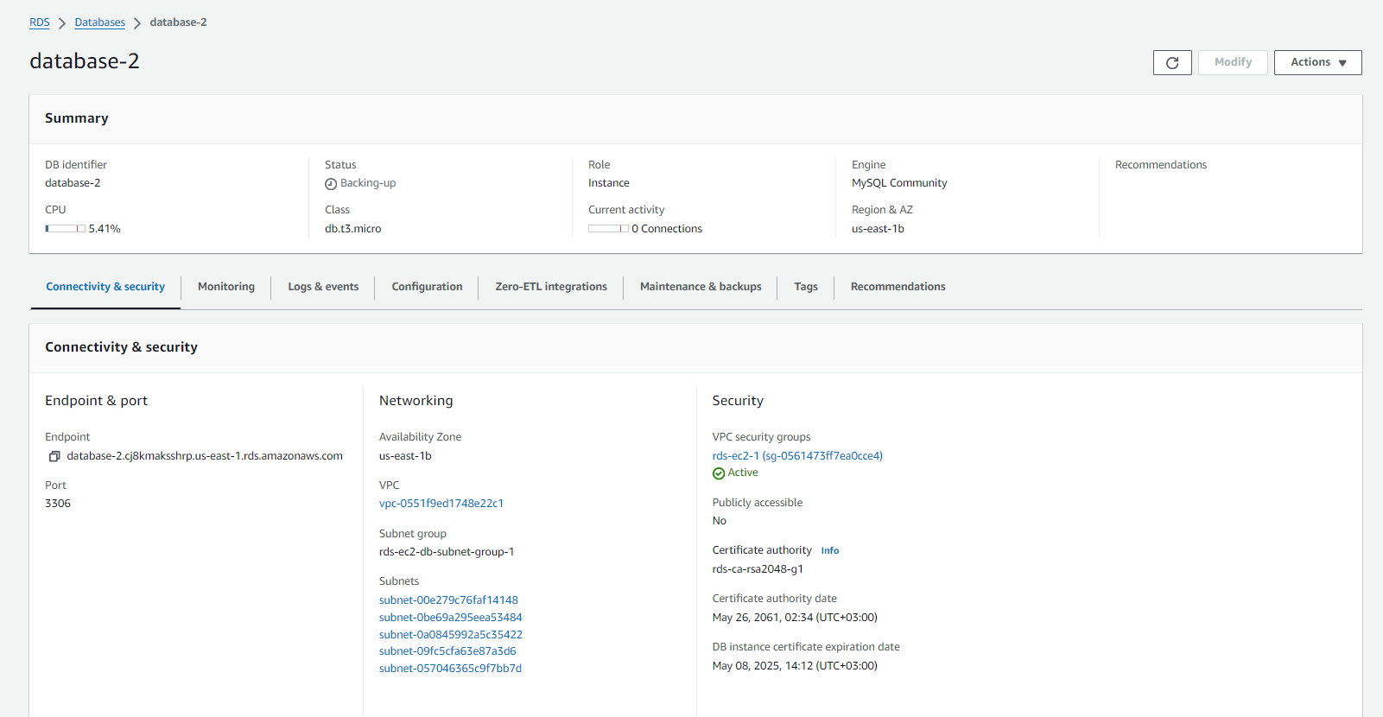

1. Create EC2 Instance

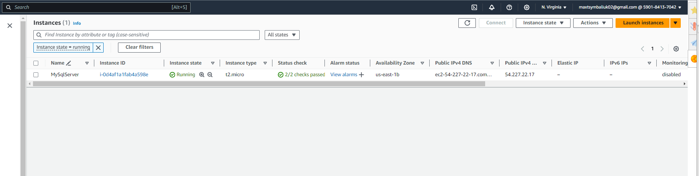

1. Connect to DB with mysql util from that instance

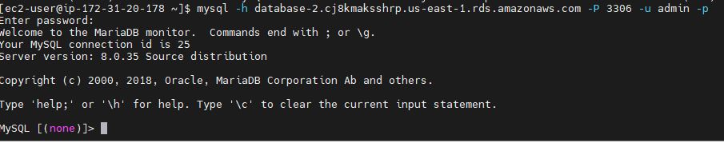

1. Create some table

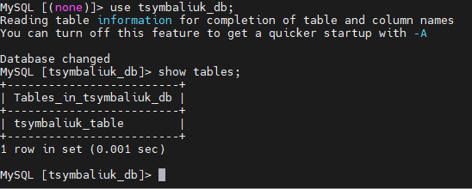

1. Insert values to that table



1. Get items from the table

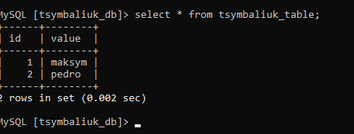

1. Delete RDS and EC2

Done